

HELLENIC REPUBLIC
MINISTRY OF FINANCE
GENERAL SECRETARIAT OF ECONOMIC POLICY
GENERAL DIRECTORATE FOR ECONOMIC POLICY

Athens, August 2017
Briefing Note

THE GREEK ECONOMY: RECENT ECONOMIC DEVELOPMENTS
OVERVIEW
- The Greek economy has moved during the last two years from a state of prolonged economic crisis to a state of economic recovery. The first signs of solid growth, declining unemployment rate, and increasing confidence in the economy are now evident. Early data on 2017 signal a trend of positive GDP growth, forecasted by the European Commission and IMF to be 2.1%.
- The fiscal performance has strengthened significantly in recent years, producing in 2016 a primary surplus of 4.2% of GDP, which is the higher in at least the past 25 years and overly exceeds the program’s target of 0.5%. The headline fiscal balance turned also positive for the first time in 2016 (0.7% of GDP), so that the European Commission recommended a closure of the Excessive Deficit Procedure (EDP) for Greece (Graph 1).
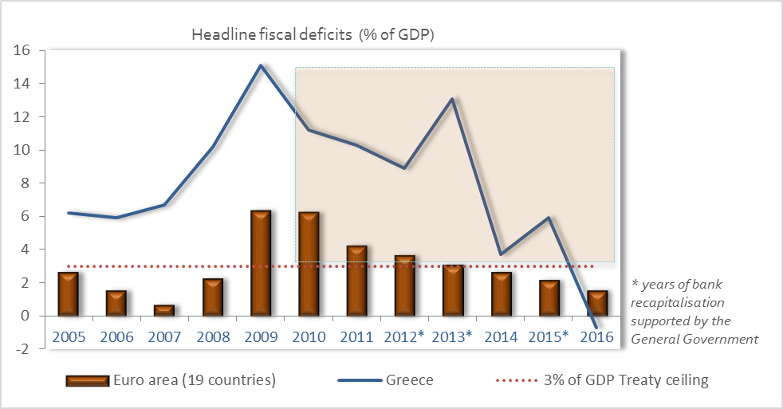
Graph 1: The magnitude of fiscal consolidation in the adjustment period
Source: Eurostat
- The unemployment rate is on a downward trend, from 24.9% in 2015 to 23.5% in 2016 and 22.4 in the first four months of 2017.
- The increased confidence in the economy, following the conclusion of the second review of the ESM program and the approval in principal of a Stand-By-Arrangement by the IMF, will boost consumption and private investment, through improved economic sentiment.
- Credit rating agencies (Moody’s and Standard and Poor’s) have recently changed the Greek economy’s outlook from stable to positive. Moody’s has also upgraded long-term issuer rating and all senior unsecured bond and program ratings.
MACROECONOMIC DEVELOPMENTS
After seven consecutive years of economic adjustment, under a changing policy mix of fiscal consolidation and structural reforms, the Greek economy is now on a sustainable corrective track of its main macroeconomic figures.
Especially with regard to the fiscal trajectory, projections for the medium term are favorable, in line with Greece’s commitment to maintain primary surpluses at 3.5% of GDP between 2018 and 2022 under the ESM program (Graph 2).
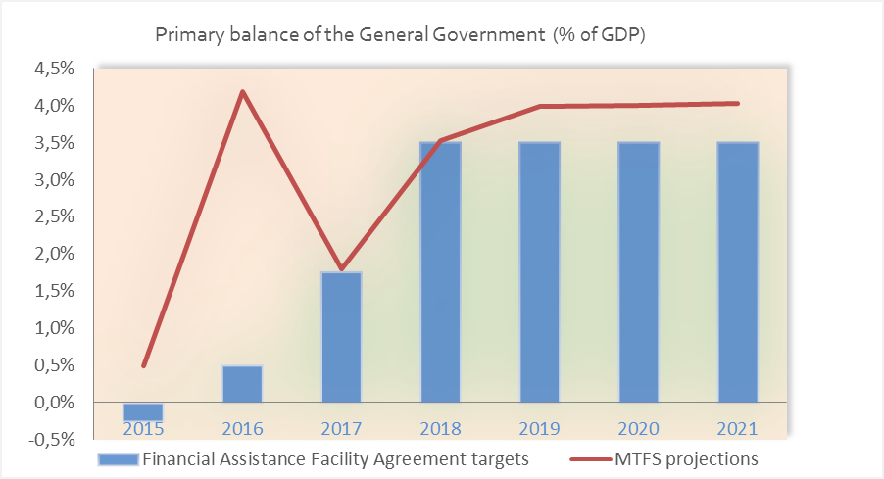
Graph 2: Estimates of performance in the primary GG balance
Source: MTFS 2018-2021 (estimates based on the methodology of the Financial Assistance Facility Agreement)
Since March 2017, the 10-year government bond yield has been on a downward track, on the back of concrete progress made towards the completion of the second review (Graph 3). In June 2017, the final agreement on the review’s policy package entailed a medium-term holistic solution for fiscal sustainability, growth enhancement and social cohesion.
The focus on medium-term, lasting results infused greater credibility of the ESM program, which shall effectively turn into a swift pick-up in confidence. Moody’s and Standard and Poor’s have already changed Greece’s outlook from stable to positive, and impetus has been given to Greece’s return to the international financial markets at sustainable rates. In July 2017 came the first attempt of accessing international markets under the ESM support program, under which €3 billion of 5-year bonds issued at a 4.625% interest rate. This rate is below the 4.95% rate of 2014, when the country had last accessed the markets.
The bond issue is a milestone in the seven-year financial crisis, and paves the way to proceed with further bond issues before the end of its bailout program. Given the fact that part of the issued bonds were used to switch a previous 5-year bond, which matures in 2019, and part to accumulate a cash buffer for which a bank account in the Bank of Greece has already been opened, shows that there is a planned schedule that Greece will be able to end its dependence on international rescue loans when the bailout program ends in August 2018.

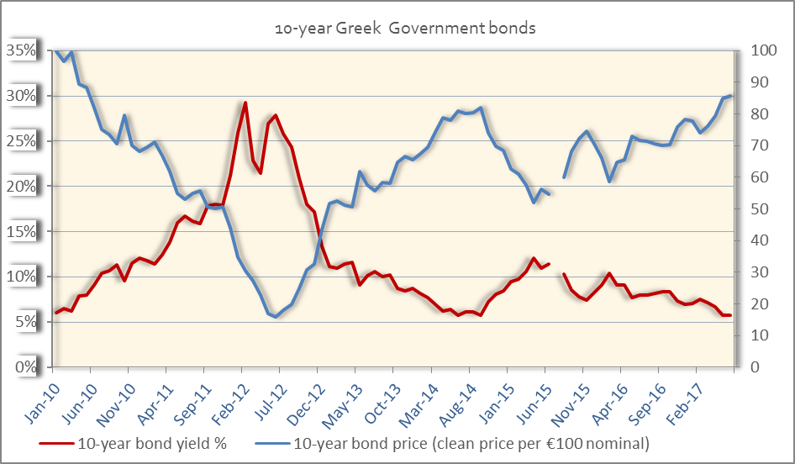
Graph 3: Prices and yields of the 10-year Greek Government bond in the adjustment period
Source: Bank of Greece

Year 2016: Resilience despite lingering effects of economic disturbance
During the course of 2016, discussions on the first review of the ESM program went uninterrupted, inducing a prospect-reassuring effect on the economy, valued in terms of liquidity and expectations. Shortly after the review’s completion, ECB reinstated the eligibility of Greek bonds used as collateral in Eurosystem monetary policy operations. This has thenceforth reduced the dependence of the Greek banks on the Emergency Liquidity Assistance (ELA) mechanism and lowered their borrowing costs.
From the demand-side approach, 2016 was a year of stable gross domestic output on the back of robustly recovering real private consumption (at a 1.4% rate year-on-year) and bottoming-out losses of nominal gross fixed capital formation (at a 0.8% rate year-on-year).
Resilience of gross fixed capital formation was more evident in terms of volume, as it was sustained at the level of 2015, marking increases in constructions other than housing (2.9% year-on-year) and in machinery (2.4% year-on-year), against decreases in transport equipment (-5.9%) and housing (-12.8%).
Prices were unchanged compared to 2015 based on HICP averages, after having languished in deflation for 3 years. The GDP deflator was marginally positive, at 0.1% year-on-year, as compared to the -1.4% year-on-year average rate in the period 2012-2015.
According to the EDP tables (excluding one-off fiscal costs of support to the banking system), the primary surplus of 2016 was €6.9 billion versus a €0.7 billion in 2015. This implies an eight-times-above-target fiscal performance, at 4.2% of GDP based on the Economic Adjustment Program (EAP) methodology.
As regards the labor market, there was a further decrease of the unemployment rate compared to 2015 and 2014 (from 26.5% in 2014 to 24.9% in 2015 and 23.5% in 2016), while the annual employment rate increased by 1.7pp on average compared to 2015. Improvement was also recorded in the youth unemployment rate, which fell to the (albeit high) average of 47.4% of the youth labor force, compared to 49.8% in 2015, as well as in the long term unemployment, which decreased to 72.0% of total unemployment compared to 73.2% in 2015.
Year 2017: Evidence of economic recovery amid ongoing reforms
The ESM program has been well on track throughout 2017, now heading to the third review with a pack of strategies for the ultimate lift of capital controls, public and private debt restructuring, and growth-friendlier future deployment of fiscal policies. These strategies, which were determined under the second review of the ESM program, are expected to strengthen confidence and momentum.
In Q1 2017, real GDP has increased by 0.4% year-on-year and quarter-on quarter (estimate). Recovery was resumed on the back of a significant increase in real private consumption (+1.7% y-o-y) and real public consumption (+1.0% year-on-year), as well as of a base year effect in gross fixed capital formation (at +11.2% year-on-year).
The 4.4% year-on-year increase in real exports of goods also contributed, despite the large increase in international oil prices that led to competitiveness losses in exports beyond the energy market. In the first five months of 2017, the current account balance was improving year-on-year, due to increases of surpluses in the services balance and the balances of primary and secondary income, which offset the deterioration in the oil balance stemming from the oil price hike.
Prospects for 2017 remain high, as economic climate and investors’ appetite for the Greek market are expected to pick up on the back of the:
(a) Short-term public debt sustainability measures and specified medium-term ones,
(b) Supervisory measures for the containment and restructuring of private debt,
(c) Speeding-up of the privatization program and arrears payment program,
(d) Holistic national growth strategy (including the creation of a national development bank and the exploration of new financial instruments),
(e) Roadmap for the lift of capital controls,
(f) Ongoing fiscal over-performance in the first half of 2017 (related to the EC’s recommendation for the closure of the Excessive Deficit Procedure), and
(g) Mindful steps towards the return to the international debt markets (the first one successfully made in July 2017).
The favorable economic conjuncture stemming from these parameters has caused, already in July 2017, Moody’s and Standard and Poor's to change their assessment of Greece’s outlook from stable to positive.
Meanwhile, developments in the labor market have been supporting the recovery in domestic demand. In the first four months of the year, the unemployment rate receded by an additional 1.5 pp to 22.4% versus 23.9% in the respective period of 2016. Youth unemployment was down in the first quarter, at 46.8% with respect to 50.9% in the first quarter of 2016, amid a labor force decline by 0.7% year-on-year. Active labor market policies, as well as the reformed Greek social assistance system built around the Guaranteed Minimum Income scheme, are vehicles for the offset of social impacts from the economic adjustment.

Conjunctural indicators reflect economic recovery
Soft data on expectations show a further amelioration in 2017 with respect to 2016. In the first six months of the current year, the business expectations index in industry outperforms the respective of 2016 (91.6 bps versus 91.3 bps), same as the economic sentiment indicator, which improved to 93.9 bps versus 90.5 bps in the first six months of 2016.
The general index of industrial production recorded a rise by 6.8% in the first five months of 2017 against a 0.9% increase in the respective period of 2016. On the other hand, the purchasing managers' index and the Index of business expectations in retail trade have deteriorated within 2017 as compared to 2016, which is however not depicted in the rising turnover indices in retail and wholesale trade (in either values or volumes).
Fiscal over-performance in 2017 continues amid structural changes in the economy
While part of the surplus in 2016 was one-off, a significant part of the 2016 surplus was structural and therefore will hold forward to the following years. Early indicators suggest that the over-performance was the result of the tackling down of tax evasion as well as of deep structural changes in the economy, such as a shift from the informal to the formal sector and increased efficiency of firms during the crisis.
Based on parametric fiscal measures, the fiscal performance continues to be strong in 2017, yielding a primary surplus close to 1 percent of GDP above target for the first six months of the current fiscal year. The recommendation by the European Commission to close the Excessive Deficit Procedure for Greece provides strong evidence of sustainability in public finances.
New investment dynamics under a holistic strategy
Over the financial period 2014-2020, Greece will receive €35 billion of EU funds, including €20 billion from the European Structural and Investment Funds and €15 billion from Agricultural Funds.
Moreover, at half way through 2017 the operations under the Juncker Plan’s European Fund for Strategic Investments (EFSI) represented a total financing volume of EUR 1.2 billion, which is expected to trigger EUR 3.4 billion in investments. The projects focus on the areas of infrastructure and innovation (8 approved projects amounting to EUR 979 million) and SME financing (7 approved agreements with financial intermediaries (banks, funds, etc) worth EUR 195 million, with some 3,538 smaller companies or start-ups to benefit from this support).
In December 2016, the Hellenic Republic and the European Investment Bank Group launched a new risk capital Fund-of-Funds, with 200 million euro from the European Regional Development Fund and 60 million euro from the European Investment Fund (which will include up to 10 million euro from EFSI-supported resources). This new instrument will finance independently managed funds, supporting technology transfer funds in Greece and kick-start investments into accelerator funds, and boosting equity financing for high-growth SMEs.
Precisely under this scope, the holistic growth enhancing strategy that Greece is developing includes:
- Exploring options for mobilizing additional funds from international financial institutions (such as the EIB and EBRD),
- Working with the European institutions on the creation of a National Development Bank that would coordinate the implementation of development and promotional activities,
- Ensuring that, apart from the nearly EUR 11 billion absorbed since July 2015, additional EUR 970 million of EU Funds (available after the review of the national cohesion policy funding envelopes for the period from 2017 – 2020), are fully absorbed in investment supporting jobs and growth,
- Building a more growth-friendly and investment-appealing economic environment, through structural reforms (in the juridical system, the corporate tax income, the public administration),
- Gradually returning to the financial markets, using cash buffers from future disbursements of the ESM program to support investors’ confidence and facilitate market access.
Structural Reforms
Numerous structural reforms, which implemented over the past years, have triggered growth impetus in the Greek economic environment. Some of the most notable reforms are:
- Wage grids in the public sector, which have been reviewed and consolidated,
- The selection of public sector managers, which was overhauled,
- Pension funds, which have merged into a single fund with common rules,
- Product market reforms, which have been implemented under three OECD toolkits,
- Tax authority, which has become fully independent,
- Privatizations in key markets, which have progressed swiftly and
- The guaranteed minimum income scheme, which has been implemented for the entire country.
The reform effort has been one of the strongest among OECD countries. Further intensified after the legislation of 140 prior actions under the second review, the reform effort will be sustained at the same pace throughout the coming years.
Medium-term measures to debt sustainability
According to the Roadmap for the Sustainability of Greek Government Debt, as defined at the Eurogroup meeting of 24 May 2016, maintaining the sustainability of Greek government debt requires that the gross financing needs (GFNs) under the baseline scenario remain below 15% of GDP in the medium term since program completion, and below 20% of GDP over the long term.
The medium-term debt relief measures are due to implementation at the end of the program (August 2018) conditional upon the successful conclusion of the latter, and to the extent necessary for accomplishing the GFN objectives. This second set of measures, includes:
- Abolishment of the step-up interest rate margin related to the debt buy-back tranche of the 2nd Greek program,
- Use of 2014 SMP profits from the ESM segregated account,
- Restoration of the transfer of the equivalent of ANFA and SMP profits to Greece (as of budget year 2017),
- EFSF loans re-profiling within the maximum Programme Authorized Amount (deferral of EFSF interest and amortization by between 0 and 15 years),
- An operational growth-adjustment mechanism, according to which the EFSF re-profiling will be recalibrated, so as to account for possible differences between growth assumptions in the DSA and actual growth developments, and in this way ensure that both the GNF benchmarks and the EFSF Programme Authorized Amount are respected.

Robust prospects grounded on a more growth friendly fiscal policy mix
The Greek economy expected to grow robustly throughout the medium-term (Table 1). GDP growth is still set to gather pace in 2018 and 2019, reaching 2.4% and 2.6% respectively. Private consumption and investment are projected to be the main drivers of growth in 2017-2019. Based on its observed resilience, private consumption is expected to increase in 2017, supported by an increase in employment.
Main components of the Greek economy
(% annual changes, constant prices)
 | 2016 | 2017 | 2018 | 2019 | 2020 |  | 2021
GDP | 0.0 | 1.8 | 2.4 | 2.6 | 2.3 |  | 2.2
Private consumption | 1.4 | 1.3 | 1.4 | 1.3 | 1.2 |  | 1.2
Public consumption | -2.1 | 0.1 | 0.1 | 0.5 | 0.5 |  | 0.4
Gross fixed capital formation | 0.1 | 5.9 | 10.8 | 12.1 | 9.6 |  | 7.7
Exports of goods and services | -2.0 | 3.3 | 4.0 | 4.4 | 3.2 |  | 3.0
Imports of goods and services | -0.4 | 2.8 | 3.5 | 4.3 | 3.1 |  | 2.9
GDP deflator | 0.1 | 1.2 | 1.2 | 1.4 | 1.7 |  | 1.8
HICP | 0.0 | 1.2 | 1.1 | 1.3 | 1.6 |  | 1.8
Employment* | 1.3 | 1.4 | 1.7 | 1.8 | 1.4 |  | 1.0
Unemployment rate* | 21.7 | 21.0 | 19.8 | 18.3 | 17.1 |  | 16.3
Unemployment rate (LFS) | 23.5 | 22.8 | 21.6 | 20.1 | 18.9 |  | 18.1
* * rates on a NA basis
Table 1: Main components of the Greek economy
Source: Hellenic Statistical Authority, Ministry of Finance
Business climate is also expected to improve, leading to the return of investment, as financing conditions may ease gradually. In 2018, investment growth will accelerate further and gross capital formation will become the main contributor of growth. Contribution of net exports is expected to turn positive too in 2017 and 2018, based on the recovering shipping sector and the increased demand experienced by the Greek tourism sector.
The new focus of the ESM support program on fiscal reforms is to improve the policy mix and facilitate a more growth-friendly and socially-inclusive budget. Through the program, reforms will also advance in improving fiscal institutions, strengthening the legal framework to deal with Non Performing Loans (NPL’s), and liberalizing product markets, while supporting the continuation of key collective bargaining reforms. These reforms, along with the anticipated debt relief, shall bolster confidence, restore macroeconomic stability, and facilitate Greece’s return to markets.

